**ELECTRO SPORT**

***Submitted by***

**Name of Student:N.SRIHARSHA**

**Registration No.12408782**

**Roll No.64**

**Section.K24KP**

***in partial fulfillment for the award of the degree***

***of***

**BACHELOR OF COMPUTER SCIENCE and ENGINEERING**



**Lovely Professional University, Punjab**

**CSE326 – Internet Programming Laboratory**

**(CA-3)**

**DECEMBER, 2024**

**TABLE OF CONTENTS**

|  |  |  |
| --- | --- | --- |
| **S NO.** | **TOPIC** | **PAGE NO.** |
| **1** | **Introduction** | **1** |
| **2** | **Technology Used** | **1** |
| **3** | **Workflow of project (Flowchart)** | **2** |
| **4** | **Project Description** | **3** |
| **5** | **Project Objectives** | **3** |
| **6** | **Expected outcomes of project** | **4** |
| **7** | **[Firstpage].html** | **5** |
| **8** | **[Secondpage].html** | **6** |
| **9** | ……………... | 8 |
| **10** | ……………... |  |
| **11** | **Output Screenshots** | 20 TO 31 |
| **12** | **Github Link** | 32 |
| **13** | **Conclusion** | 33 |
| **14** | **References** | 33 |

INTRODUCTION

Electro Sports is an innovative sports website dedicated to bringing fans the latest updates, insights, and resources from the sports world. Designed for enthusiasts who crave dynamic, real-time access to scores, player stats, game analyses, and breaking news, Electro Sports aims to provide an all-in-one hub for sports coverage. With a sleek, user-friendly interface, the platform makes it easy to dive into favorite sports, track live events, and discover unique features such as fantasy leagues, expert blogs, and fan community forums.

Electro Sports covers a wide range of sports, including football, basketball, tennis, soccer, and even emerging sports and e-sports. The site also emphasizes engaging visual content, offering highlights, exclusive interviews, and analysis videos. Whether you're a casual fan or a die-hard follower, Electro Sports strives to keep you connected, informed, and entertained across all things sports.

TECHNOLOGY USED: HTML AND CSS

FLOW CHART

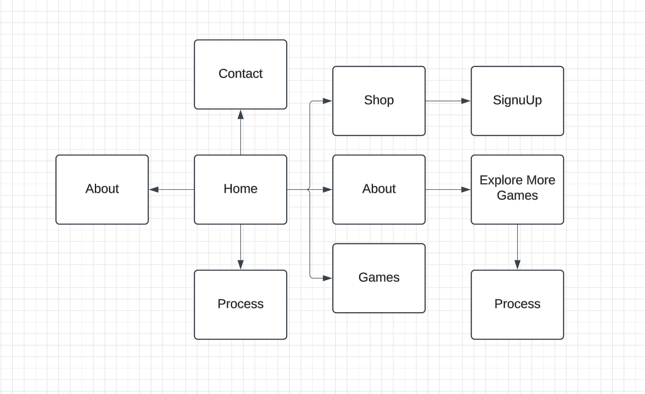

PROJECT DESCRIPTION:

Electro Sports is a cutting-edge digital platform designed to revolutionize how fans interact with the world of sports. The project’s goal is to provide a comprehensive, real-time sports experience that combines live updates, in-depth analytics, community engagement, and personalized content, all in one place. Electro Sports is aimed at both casual viewers and dedicated fans who want a deeper connection to their favorite sports, teams, and athletes.

**Key Features:**

1. **Live Score Updates and Game Tracking:**
   * Real-time scores, play-by-play commentary, and game statistics to keep fans engaged as the action unfolds.
   * Coverage spans a variety of sports, including traditional sports like football, basketball, and soccer, as well as emerging sports and e-sports.

PROJECT OBJECTIVE

Electro Sports is focused on providing a seamless and engaging sports experience to fans worldwide. The following objectives outline the project’s key goals, ensuring that Electro Sports becomes a premier sports website for live updates, insights, and fan engagement:

**1. Deliver Real-Time, Comprehensive Coverage**

* **Objective:** Ensure the site provides instant and accurate real-time updates for scores, game highlights, and player statistics across a variety of sports.
* **Outcome:** Enhance user engagement by allowing fans to stay connected to live events from any device, no matter where they are.

**2. Foster a Community of Sports Enthusiasts**

* **Objective:** Build interactive forums, discussion threads, and fan polls to encourage active user participation and engagement.
* **Outcome:** Create a community-focused platform where fans can share insights, discuss games, and connect with others who share their passion.

EXPECTED OUTCOMES

Upon successful implementation, Electro Sports aims to achieve several key outcomes that will elevate the platform’s value to users and position it as a premier sports website. These outcomes are intended to drive user satisfaction, engagement, and loyalty, helping Electro Sports stand out in the competitive digital sports landscape.

**1. Increased Fan Engagement and Retention**

* **Outcome:** High levels of user engagement through interactive features like live score updates, fantasy sports, and community forums, resulting in increased daily active users and repeat visits.
* **Impact:** Electro Sports will foster a loyal community of fans who view it as their go-to destination for sports content and discussions.

**2. Enhanced User Satisfaction through Real-Time Coverage**

* **Outcome:** A reliable, real-time feed of sports scores, stats, and updates, leading to positive user feedback and high satisfaction ratings.
* **Impact:** Fans will appreciate the accurate, timely nature of the content, building trust and preference for Electro Sports over competitors.

HOME.HTML









HOME.CSS

















ABOUT.HTML



ABOUT.CSS



EXPLORE MORE GAMES.HTML





GAME.HTML





GAME.CSS







CONTACTUS.HTML





GALLERY.HTML







SHOP.HTML







SHOP.CSS





SIGNUP.HTML









EXPECTED OUTCOMES

HOME



ABOUTSPORT



EXPLORE MORE GAME



GALLERY







CONTACT

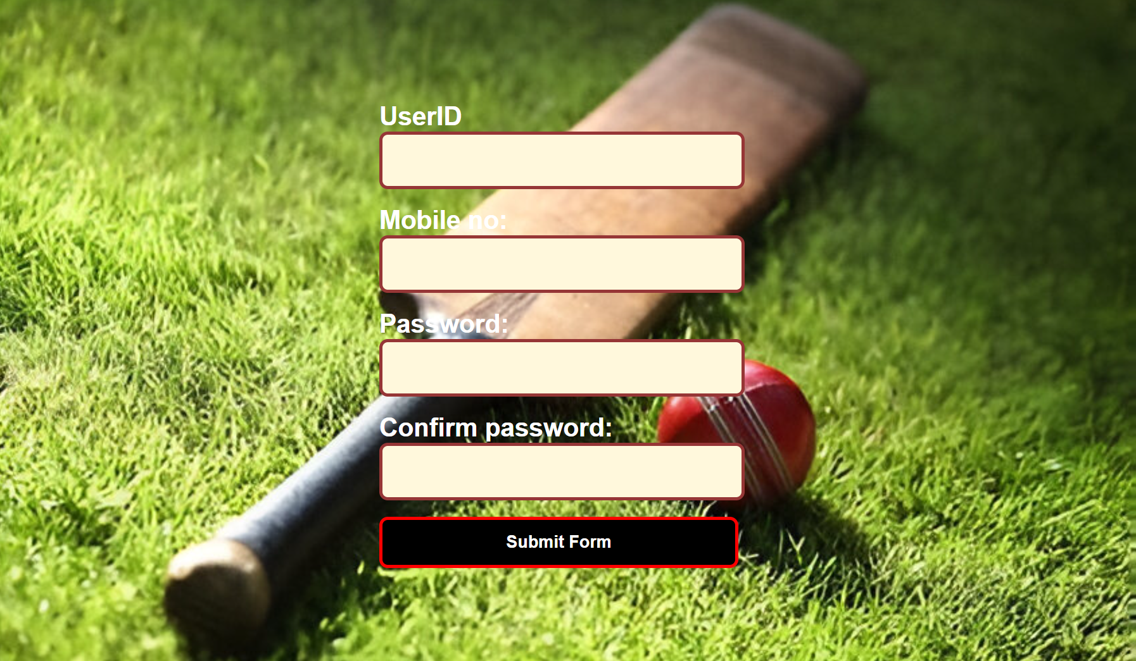

GALLERY







SHOP



SIGNUP



GITHUB LINK:

[harsha-2728/SPORTS-WEBSITE](https://github.com/harsha-2728/SPORTS-WEBSITE)

CONCLUSION:

Electro Sports represents a forward-thinking, comprehensive solution for sports fans who crave real-time updates, in-depth analysis, and an engaging community experience. By blending cutting-edge technology with user-focused features like live scores, personalized content, fantasy leagues, and a robust community, Electro Sports is poised to transform how fans interact with their favorite sports.

The platform is designed to be a one-stop destination for fans of all types—from casual viewers to devoted enthusiasts—offering everything from live updates to expert commentary. Through its innovative approach and commitment to accessibility and inclusivity, Electro Sports aims to reach a global audience, fostering a vibrant and dynamic community that connects fans to the excitement of the sports world.

**REFERNCES :**

*Electro Sports* draws inspiration from or aligns with existing sports websites, platforms like *ESPN*, *Bleacher Report*, and *Yahoo Sports* might serve as useful models. These platforms offer similar